

**To:** Dr. Helen Yu

**From:** Dominic Riccoboni

**Subject:** EE513 Term Project

**Date:** March 15, 2021

Ball Balancing Platform Overview

The Cal Poly Mechanical Engineering department has produced a ball balancing platform to bring the learn by doing experience to students taking the Intro to Mechatronics and Mechatronics courses remotely. The system consists of a plate attached through u-joint mechanism to the ground, a touch screen panel on top of the plate to measure the position of a rolling ball, and two DC motors to apply torques to the plate through connecting rods (figure 1).

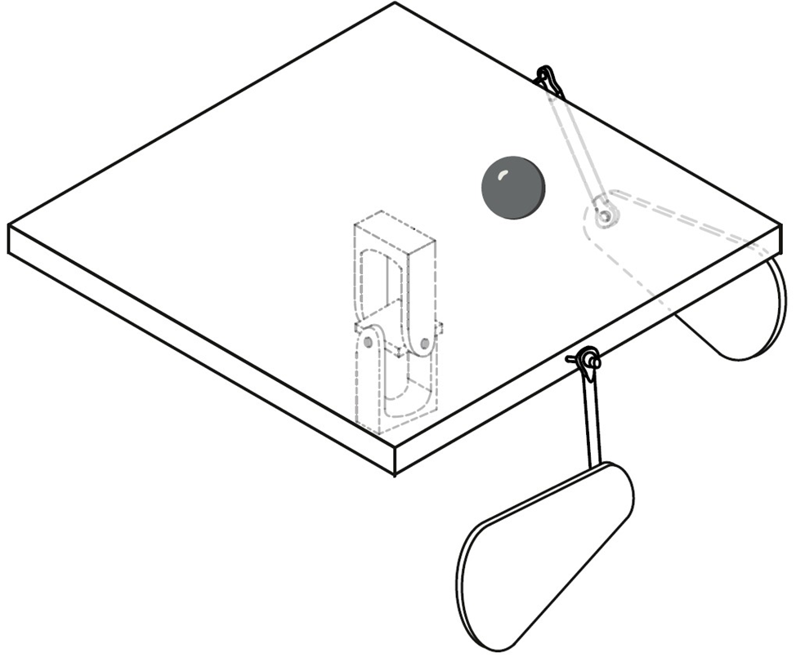

Figure 1. Schematic of the ball balancing platform

The system aims to balance the ball at an unstable equilibrium, with the platform perfectly horizontal and the ball centered on the touch panel. The project provides a fantastic opportunity for students to apply mechatronics and controls principles to a real system. They will have the opportunity to perform dynamic analysis and derive the equations of motion, to interface with sensors and actuators, and implement their own control algorithms.

Abstract

The full nonlinear model of the ball and plate system is derived using minimal assumptions. Three dimensional kinematic and kinetic analysis is performed on the system to derive the equations of motion. These equations of motion are formulated in terms of the state variables that describe the degrees of freedom of the system – two translational degrees of freedom for the ball, and two rotational degrees of freedom for the plate. A Jacobian linearization is performed about the unstable equilibrium point corresponding to a zeroed state vector – the plate being perfectly horizontal, and the ball centered on the plate. The state space model is formulated, and the controllability and observability of the linear system is determined. The system is found to be both fully controllable and fully observable and it is conceivable that future work can produce a full state feedback regulation controller to drive the system to its unstable equilibrium point.

Kinematics

To derive the equations of motion of the ball and plate system, we must first find the velocity and acceleration vectors for arbitrary displacements within the plate's frame of reference. The reason we will describe most of our system with respect to the plate frame is that we are interested in the  and  location of the ball relative to the plate. It is quite easy to define these displacements in a plane and quite complicated to attempt to describe the displacement of the ball in three-dimensional space without using the methods presented here. In addition to the ease of describing the ball's displacement in the plate frame, the plate's inertia tensor.

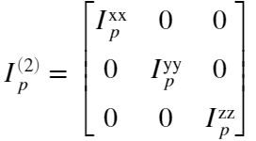

is diagonal in its own frame. Choosing S2 to describe many of its kinetic quantities is advantageous.

A schematic of the system is shown in figure 2: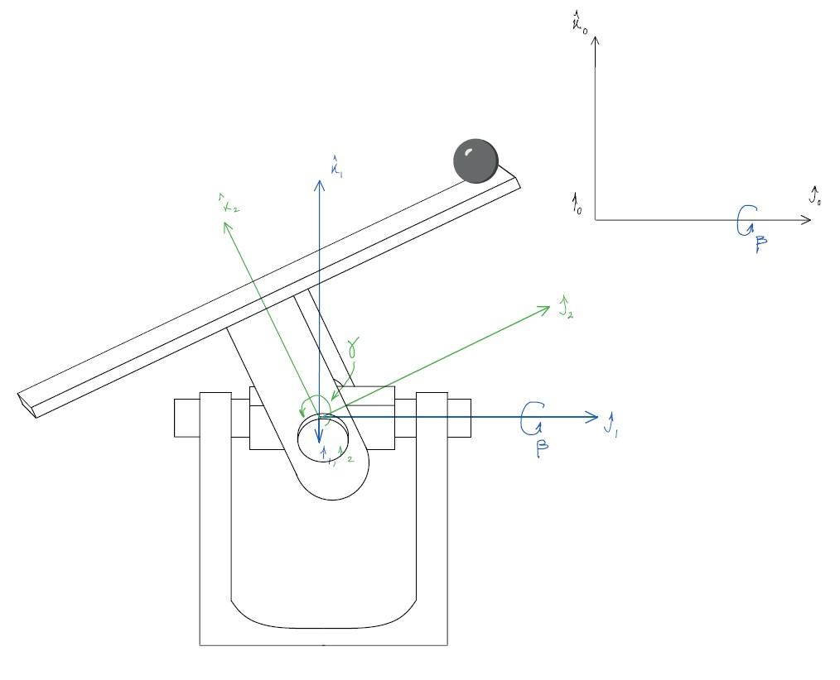

Figure 2: Schematic of the ball and plate system showing the choice of coordinate systems and associated rotation angles.

The global frame will be denoted S0, the u-joint frame will be denoted S1, and the plate frame will be denoted S2. Frame S0 is the inertial frame of reference - differentiation of kinematic and kinetic quantities will occur with vectors expressed in this frame. In this way, results will be compatible with Newton's laws of motion. The S1 frame is attached to the u-joint block, it is fixed with respect to the joint's axles of rotation. S1 rotates about a shared y axis with S0 through angle . Frame S2 rotates about a shared x axis with frame S1 through angle . The rotation matrices associated with these,  are defined in appendix 1.

# Notes on Notation for the Kinematic Analysis

* Lower indices follow Einstein summation convention where no distinction is made between the covariant and contravariant parts of a tensor (all rotations are proper orthogonal).
* Superscripts label the term and should not be confused with indices.
* For rotation matrices, the superscripts indicate the frames being transformed between. The first number indicates the frame that the second frame's basis vectors are being composed in. Or put in another way, the first frame is observing the motion of the second frame's basis vectors and describing them in terms of its own basis vectors. If a set of basis vectors are being composed in another frame, they will be given the clarification "(t)" to indicate that they are now, generally, time varying vectors in that frame. The rotation matrix will multiply the first frames stationary basis vectors on the left as such:

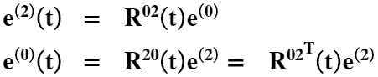

* Superscripts on first order tensors indicate the frame in which its components are expressed in. For instance,  is the displacementvector whose components are correct when its component array  is dotted with the  basis vectors. The vector would not be properly represented if dotted with the  basis vectors.

# Methodology

The positions, velocities, and accelerations for the system are derived below. In finding the velocity of an arbitrary displacement vector in frame S2, we also find the angular velocity of the plate frame.

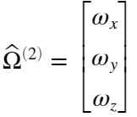

expressed in the plate's basis vectors. This, in addition to the linear velocities and accelerations is a very important vector in the kinetic analysis - it helps to describe the angular momenta of the ball and the plate that will be utilized in the sum of the moments in the Newton-Euler kinetic analysis.

## Position

1. Define an arbitrary displacement vector  whose coordinates are known in frame S2.

2. Use knowledge of how the S2 basis vectors move with respect to the S0 frame to express  in the global basis as .Since the two frames coincide at their origin, this new vector will represent the global displacement vector.

## Velocity

3. Take the first total time derivative of . This will be the absolute/global velocity of the displacement vector (still expressed in the global basis).

4. Rotate the basis vectors back to S2 by applying to the basis vectors only, the inverse of the rotations applied in step 2. In doing this, find our  matrices.

5. Obtain our Omega matrix, the angular velocity matrix of the frame S2 as observed in the global frame, expressed in the S2 basis.

## Acceleration

6. Rotate the velocity vector from step 5 back to the S0 basis.

7. Take the time derivative of the velocity vector to acquire the global acceleration vector.

8. Rotate the vector back to the S2 basis.

# Define Arbitrary Displacement Vector

## Step 1

Define , the displacement of a point relative to the origin of S2 expressed in the S2 basis:

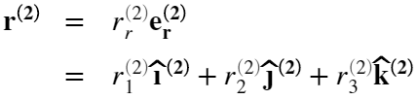

## 

## Step 2

In the S0 frame, the S2 basis vectors are rotating. The two bases share a common origin:

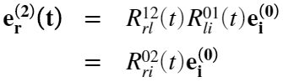

Define , the displacement of a point relative to the origin of S2 expressed in the S0 basis.

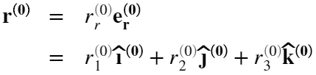

Since  and  are tensors representing the same physical entity, they are equivalent. We can utilize this fact along with the knowledge of how the S2 basis vectors rotate in S0 to express  in terms of the components of :

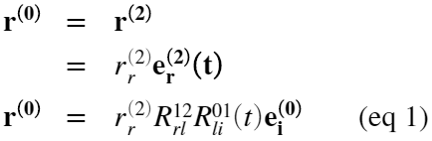

## Result: Displacement

Written out fully in terms of the angles  and , the arbitrary displacement vector of S2 rotated into S0:

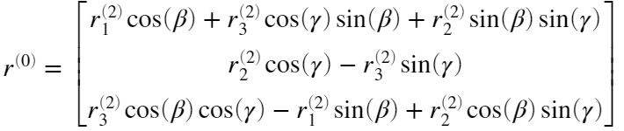

Since the frames S2 and S0 always share a common origin, a change in the basis used to represent the displacement in S2 coincides with the description of a displacement in S0. For convenience, we will call  the global displacement vector because they are effectively equivalent.

# 

# Differentiate to Obtain Global Velocity Vector

## Step 3

We take the total time derivative of equation 1.

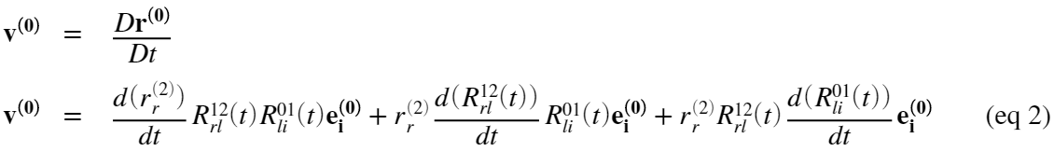

Equation 2 has three terms on the right-hand side:

1. This is the relative velocity term - the rate of change of the motion of r within its own frame S2, holding all other terms constant.
2. The rate of change of  that comes from the motion of frame S2 within the frame S1, holding all other terms constant. As if the vector  is constant in S2 and the frame S1 is constant in the global frame S0.
3. The rate of change of  that comes from the motion of frame S1 within S0, holding all other terms constant.

## Step 4

By differentiating the global displacement vector, we have attained the velocity of the vector originally defined in S2 with respect to an inertial reference frame. We are then free to rotate our basis back to the intermediate frame S2. This will express those absolute quantities in a convenient set of basis vectors:

### Term (1)

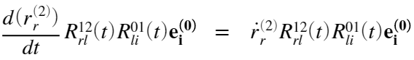

Here,  are the time derivative of the components of , the components of displacement belonging to S2. These components are the  terms.

### Term (2)

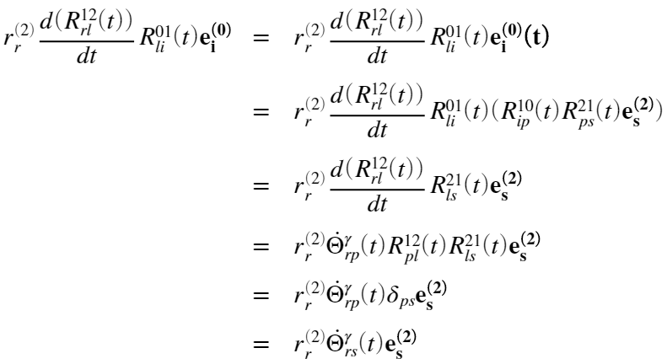

Where:

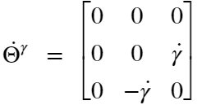

It can be shown that the components 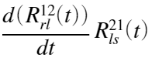 are equivalent to the components . This  matrix was obtained by . The matrix can also be obtained by factoring out  from  on the right  .

### 

### Term (3)

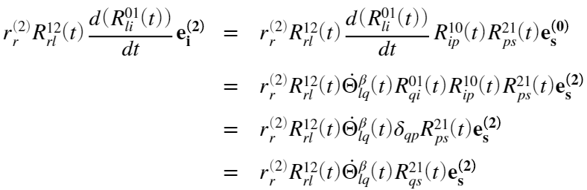

Where:

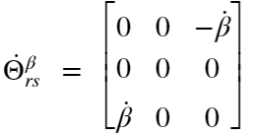

## 

## Step 5

Terms 1-3 are now elements of  since the basis vectors contained in them belong to S2. We will group these terms to find the  3x3 matrix. This will be the angular velocity matrix of the S2 frame's motion in S0. Left multiplying a 3x1 vector **r** by this 3x3 matrix is equivalent to the cross product between the  *vector* and **r**:

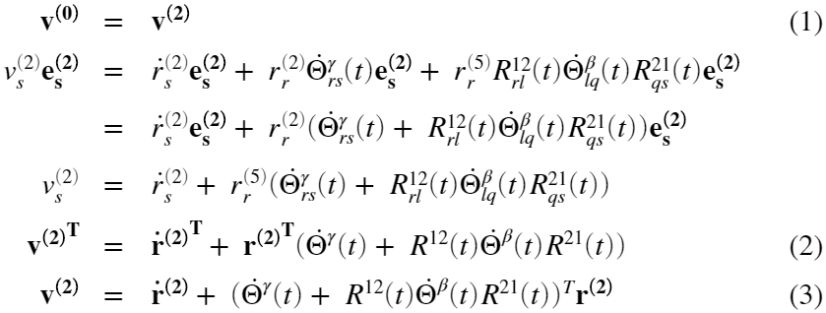

At (1), the invariance of the velocity vector under a coordinate transformation is acknowledged. Though we differentiated r(0) to get v(0), we can write v(0) in the S2 basis without changing what the vector represents, the global velocity of the global displacement vector.

At (2) we switch to matrix notation from indicial notation and more readily observe that throughout this analysis, the vector r has been a transpose (the dot product of its components with its basis vector array requires that it be transposed). At (3) we take the transpose of both sides to get the  matrices to multiply **r** (not its transpose) on the left. We then, at equation 3, rename the terms in the parentheses - this is the angular velocity of the S2 frame within the global frame; its components, however, are expressed in the S2 basis. Here we attain the velocity equation, in an absolute sense, for an arbitrary displacement vector in the rotating frame S2, expressed in the S2 basis.

We have arrived at



Where



In general, its components are the global angular velocities of the intermediate frame S2 expressed in its own basis.

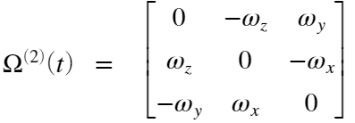

It can be seen in equation 3 that no rotation matrices multiply . This is because the axis of rotation for  is fixed in the S2 frame - there is no transformation required to determine the direction of the contribution from  to the frame’s angular velocity vector, it’s always in the frame's  direction. Two matrices multiply ; one on the left and one on the right. This turns out to be a similarity transform on whose components are expressed in the S1 basis. The axis of rotation for  is moving with respect to S2 and therefore its contribution to the frames angular velocity vector is also changing direction - this is realized in the similarity transform between the two frames.

## 

## Equivalence of the cross product and matrix multiplication for Capitol Omega

Equation 3 can be rewritten as



where is a vector containing the angular velocities from 



and matrix multiplication has been exchanged for the cross product.

Our derivation of the  matrix from differentiation of rotating vectors led us to knowledge of the components of the vector. This vector is more useful to our kinetic analysis than the matrix because the angular momenta in the system are defined in terms of the vector and not the matrix.

## Result: Global Velocity and Angular Velocity

The global angular velocity matrix of the plate in terms of u-joint angles - S2 basis:

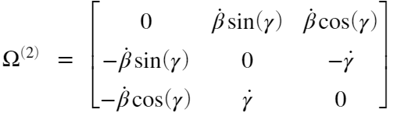

The global angular velocity vector of the plate in terms of u-joint angles - S2 basis:

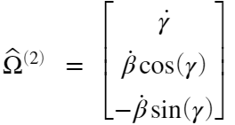

The global velocity vector of an arbitrary displacement within frame S2 written in the S2 basis:

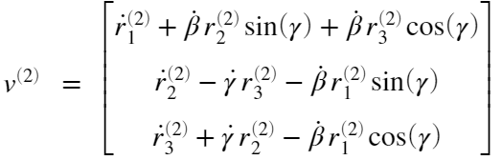

# Differentiate to Obtain Global Acceleration Vector

## Step 6

Rotate  back to the S0 basis, obtaining .

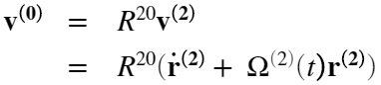

## 

## Step 7

Differentiate  to obtain the global acceleration vector.



## 

## Step 8

Rotate back to the S2 basis to describe the global acceleration in the plate's basis.



## 

## Result: Global Acceleration

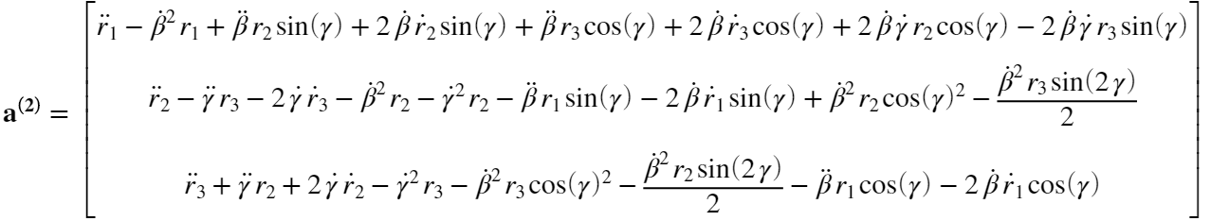

Ball and Plate Kinematics

Now, we must substitute the arbitrary displacement vector components from the kinematic analysis for meaningful displacement vectors of our system. We will choose the centers of mass of the ball and the plate. In doing so, we will obtain the global velocities and accelerations of the mass elements of our system for use in force analysis.

# Ball Kinematics

We will substitute in the displacement vector to the ball's center of mass defined in the plate's basis with the arbitrary displacement vector . Any differentiated component of  must become a differentiated component of the substituted displacement vector. The ball's displacement vector in the plate frame will contain the two variables that we will later use as state variables - its x and y components. These describe the position of the ball with respect to the surface of the plate. The z position of the ball in the plate frame, , is constant because the ball never leaves the plate.

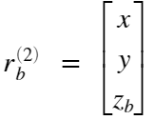

Substituting  into the velocity equation, we get:

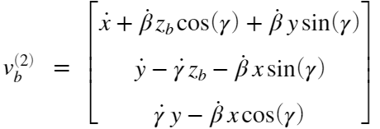

Substituting  into the acceleration equation, we get:

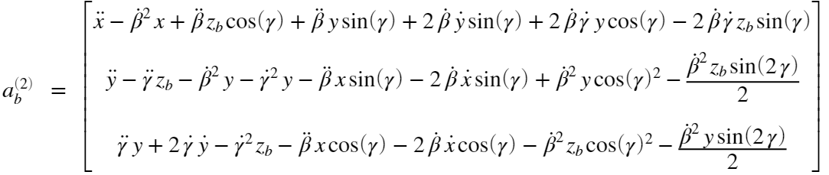

# Rolling Without Slip Constraint

This condition will relate  and  of  to  and . The vector  is defined to be the ball's angular velocity within the plate frame:

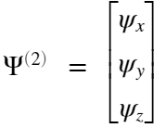

We assume that the ball is rolling about the plate's surface without slipping. This assumption allows us to relate  to the relative velocity of the ball  through the cross product.

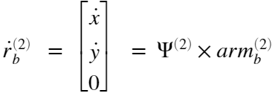

where  is the moment arm between the ball's contact point with the plate and the ball's center of mass expressed in the plate frame.

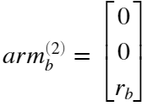

In doing this, we can express the ball's angular velocity in terms of variables we desire for our state vector,  and . Solving for the angular velocity components in the above cross product yields:

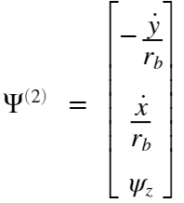

Here,  is leftover, but it will be irrelevant to the dynamics of the ball that we will be concerned with.

# Ball Kinematics

We will substitute in the displacement vector to the plate's center of mass defined in its own basis with the arbitrary displacement vector . Just as before, any differentiated component of  must become a differentiated component of the substituted displacement vector. The plate's displacement vector in its own frame is a constant vector with only a z component, as we assume that the plate's center of mass is located directly above the origin of the S2 frame. Since this vector is utilized as a moment arm in the kinetic analysis later, it is denoted :

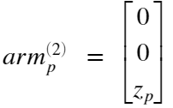

Substituting  into the velocity equation, we get:

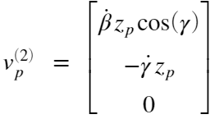

Substituting  into the acceleration equation, we get:

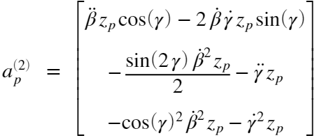

Kinetics and Deriving Nonlinear Equations of Motion

Now that the kinematics for the system have been formulated, we can move on to the Newton-Euler kinetic analysis. The sum of moment equations for the ball and for the combined ball and plate system will be used to determine the equations of motion. This analysis will further couple the states of our system together and it will bring in the externally applied torques. The flow of work to arrive at the equations of motion will be as such:

1. For both FBD = KD system, formulate the angular momentum vector/sin terms of the pertinent kinematic variables.
2. Rotate that  vector/s into the global reference frame and differentiate it/them to get the time rates of change of angular momentum.
3. Write out the sum of moments equation for both FBD = KD systems, placing the force moments on the left-hand side of the equation and the kinetic diagram moments on the right-hand side. Do this generally, in terms of moment arms and cross products.
4. Carry out the cross products to get the moment equations relating the system's dynamic variables to each other and to the externally applied torques.
5. Choose an appropriate state vector for the system.
6. Combine the moment equations of the two FBD = KD systems and isolate the highest order derivatives of the state variables. These will be the equations of motion for the system.

# Kinetics of the Ball Alone

We will sum moments in frame S2 about ball's contact point to eliminate the unknown forces. The vectors in the kinetic diagram of figure 3 must be formulated in terms of the kinematic variables found earlier in this analysis. The normal force and friction forces will be eliminated from the equation by strategically summing moments of the contact point of the ball, the point where those forces act.

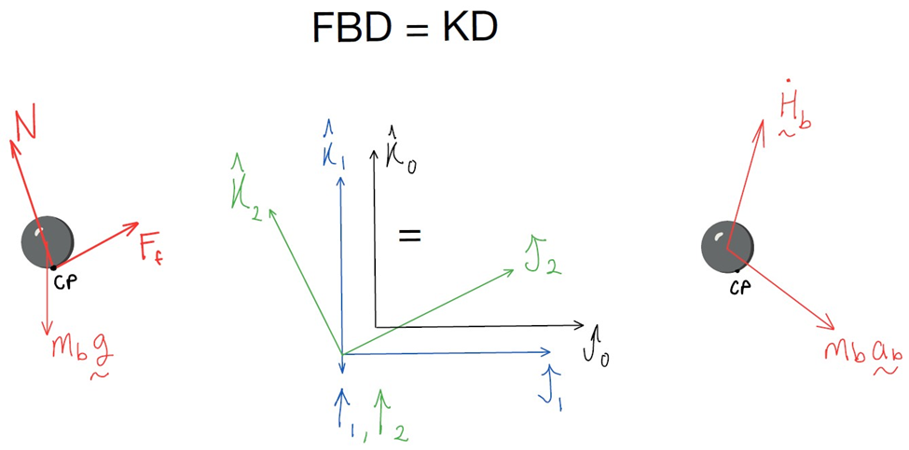

Figure 3: Free body diagram and kinetic diagram for the ball alone.  is the normal force and  is the friction force?

## Absolute Angular Momentumof the Ball About its C.O.M

This quantity is taken about center of mass of the ball and expressed in the S2 Basis. The ball's global angular velocity is the sum of the plate's angular velocity and the ball's angular velocity within the plate's frame S2. This results in an angular velocity equation of



where  is the inertia tensor of the ball?

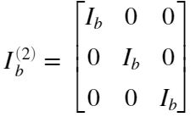

Thus, the ball's angular momentum is:

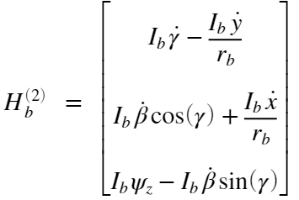

## Take the Time Derivative of Absolute Angular Momentum,, With Respect to the Inertial Reference Frame

We must transform  into the S0 global basis, take a time derivative, then transform back to the S2 basis. Taking the derivative with respect to an inertial reference frame ensures compliance with Newton's laws. The result of this procedure is:

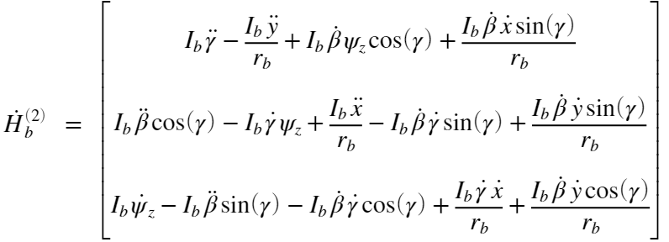

## Sum of Moments About Contact Point of the Ball

The moment arm to the ball's center of mass here is the radius of the ball  in the plate's z-direction as before



The sum of moments about point CP on the free body diagram is equal to the sum of the moments about point CP on the kinetic diagram.

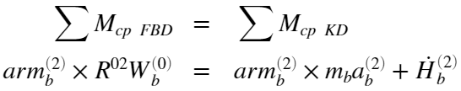

The moment equations that result are too large to fit in this context. Refer to the attached MATLAB code for detailed results.

# Kinetics of the Combined Ball and Plate System: Sum Moments in Frame S1 about U-Joint Center

We will sum moments in frame S1 about the center of the u joint. Here, the externally applied torques are easily defined. We assume that the externally applied torques of the true system can be lumped at the axles of the u joint. These axles cannot support reaction moments and therefore, any torques that exist in those directions must contribute to accelerating the mass elements of the system. The input torques are defined with respect to the S1 basis as follows:

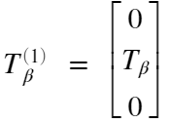

and

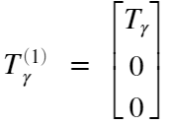

The free body diagram that relates these torques to the other system elements is shown below in figure 4. As before, the kinetic vectors on the right must be formulated in terms of the kinematics from the previous analysis. This time, the vectors will be composed in the S1 frame where the externally applied torques are of fixed direction.

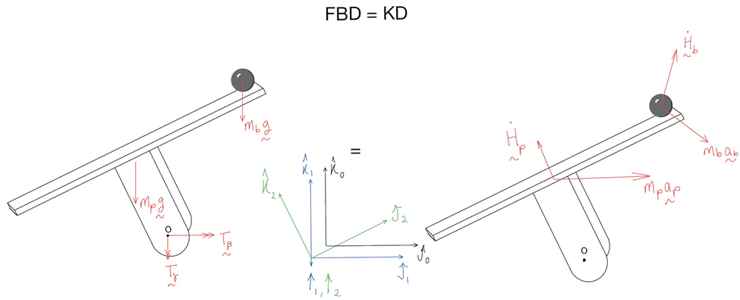

Figure 4: Free body diagram and kinetic diagram for the ball and plate combined system. and  are internal forces here so they do not appear on the diagram.

## Absolute Angular Momentum of the Plate about its C.O.M

This is taken about the plate's center of mass and is expressed in the S1 basis. First, the  vector is found, the angular momentum of the plate in the S2 frame's basis, and then it is transformed through  into the S1 frame's basis.



Where



is the plate's moment of inertia tensor. Rotated into the S1 basis,  becomes , our desired result:

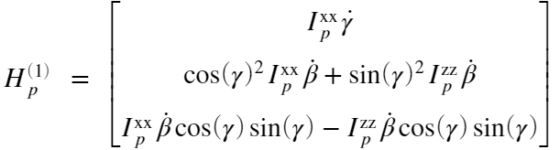

## Take the Time Derivative of the Absolute Angular Momentum, , With Respect to the Inertial Reference Frame

We must transform  into the S0 global basis, take a time derivative, then transform back to the S1 basis. Taking the derivative with respect to an inertial reference frame ensures compliance with Newton's laws. The result of this procedure is:

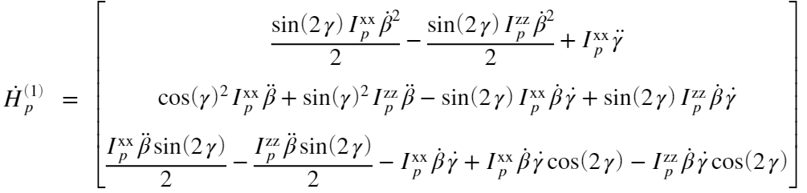

The moment arm from the center of the u-joint to the plates center of mass is rotating due to the choice of reference frame:

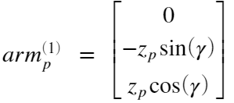

In the plate frame, this moment arm is constant, but for moments in the S1 frame, it must be rotated into the S1 basis. The moment arm to the center of mass of the ball is dynamic as well and is represented by its displacement vector in the S1 basis - we are summing moments about the origin of the coordinate systems:

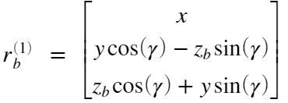

We must also bring ball and plate acceleration vectors as well as  into  into the S1 basis.

## Sum of Moments in the S1 Frame About Center of the U-Joint

The sum of moments within the S1 frame for the combined ball and plate system incorporates both body forces and the external torques about the u-joint axles:



This set of equations turns out to be far too large and cumbersome to display. Refer to the attached MATLAB code for detailed results. The code utilized is as follows:

SumMPlate = cross(armp1s, R01*Wp0s) + cross(rb1s,R01*Wb0s) + Tb1 + Tg1 + Mz1 == cross(armp1s, m_p*ap1s) + Hp1ds + cross(rb1s, m_b*ab1s) + Hb1ds;

SumMPlate = expand(subs(SumMPlate, symFunVec, symVarVec));

# 

# Bring Together Moment Equations and Solve for Highest Order Terms

The moment equations in the z directions of the analysis turn out to be unimportant. For the ball, the moments in the z direction simply tell us that there is no global external torque that can spin the ball, i.e., in the global frame, the ball maintains whatever angular velocity it has at the initial conditions. For the ball and plate together, the z direction moments simply tell us the magnitude of the reaction moment  that the u-joint takes on to support the plate and ball structurally. It does not contain any pertinent dynamics. Therefore, we will bring together only the x and y direction moment equations from each of the kinetic analysis.

The dynamics that result are functions of an important set of variables. The state vector for the system will be chosen to be



because the system is well represented with four degrees of freedom, two rotational, and two translational. The ball can move in the plane of the plate, and the plate itself can rotate through two rotation angles. The moment equations will be solved for the derivative of this vector. The resulting nonlinear equation are too cumbersome to display, but the code that was used to solve for these highest order derivatives of the state vector is shown:

EOMS = [SumMBall(1:2);SumMPlate(1:2)];

[CoeffMat,ExtTerms] = equationsToMatrix(EOMS, [x_ddot, y_ddot, beta_ddot, gamma_ddot]);

SolvedEOMs = [x_ddot; y_ddot; beta_ddot; gamma_ddot] == CoeffMat\ExtTerms;

The equations are linear in the second order derivatives and therefore the coefficients can be collected into a matrix, CoeffMat. The extra terms ExtTerms can be collected on the right-hand side of the equations with the linear terms in the double dots on the left-hand side. Inverting the CoeffMat matrix yields an isolated set of double dot terms:

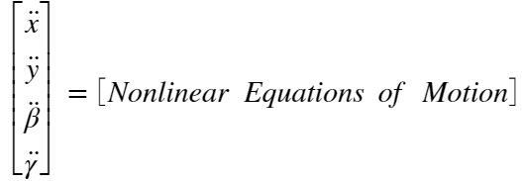

Linearize the Equations of Motion

Here, we will plug in the estimated numerical parameters of the system (figure 5) and Linearize about the unstable equilibrium point. The equilibrium point is, fortunately, characterized by a zeroing of the state vector - the plate perfectly horizontal and the ball centered on the plate. We will also have to linearize the input torques.

# Best Current Estimates of Numerical System Parameters

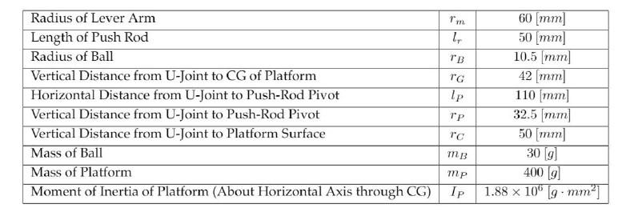

Figure 5: Estimated numerical parameters of the system.

rB = .0105; %[m]

rG = .042; %[m]

rC = .050; %[m]

mB = .030; %[kg]

mP = .400; %[kg]

IP = 1.88e6*(1/1000)*(1/1000)^2; %[kg*m^2]

IB = (2/5)*mB*rB^2;%ball inertia [kg-m^2]

g_num = 9.81; %[m/s^2]

Num_Params = [rB rC+rB mB mP IP IB g_num rG];

Sym_Params = [r_b z_b m_b m_p I_p__xx I_b g z_p];

# Final Assumptions

We are going to assume that the angular velocity of the ball in the z direction, , is insignificant and set it to zero. We will also assume that the rate of change of this angular velocity, , is zero. These should prove to be very accurate assumptions because the plate does not have the ability to impart a "spinning" force on the ball through its contact patch with the plates surface. The ball's spin will remain relatively close to zero so long as its initial spin is very close to zero.

Assumption_Params = [psi_dot_z psi_z];

Assumptions = [0 0];

Substituting known numerical parameters and our assumptions into the symbolic equations of motion:

NumEOMs = subs(SolvedEOMs, [Sym_Params Assumption_Params], [Num_Params Assumptions]);

# 

# Jacobian Linearization of the Numerical EOMs

The Jacobian Linearization is only manageable when the operating point is plugged in. This will happen below, but the Jacobian is implemented in MATLAB as follows:

The Jacobian of the equations of motion with respect to the state vector is taken.

J_states(stateVec) = jacobian(rhs(NumEOMs), stateVec);

The Jacobian of the equations of motion with respect to the input vector is taken. The input vector is chosen to be .

J_input(stateVec) = jacobian(rhs(NumEOMs),inputVec);

## 

## Form the State Space Model

The linearization allows us to formulate the system as a linear time invariant system of first order differential equations - this state space formulation is



where  and .

The resultant system in terms of the numerical values is

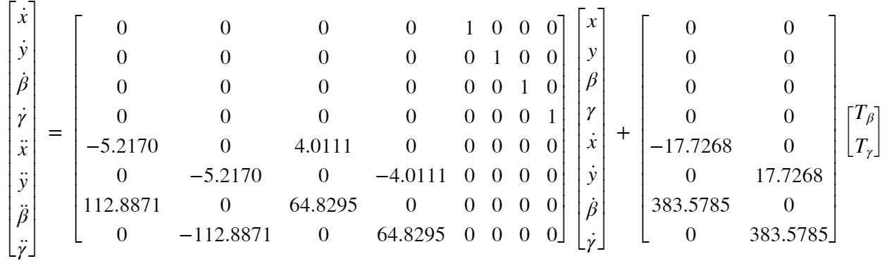

It is a bit difficult to visualize immediately, but this eighth order system has been decoupled into two fourth order systems through the linearization process. The state space model can be rewritten with a reformulated state vector  to better show that it's decoupled.

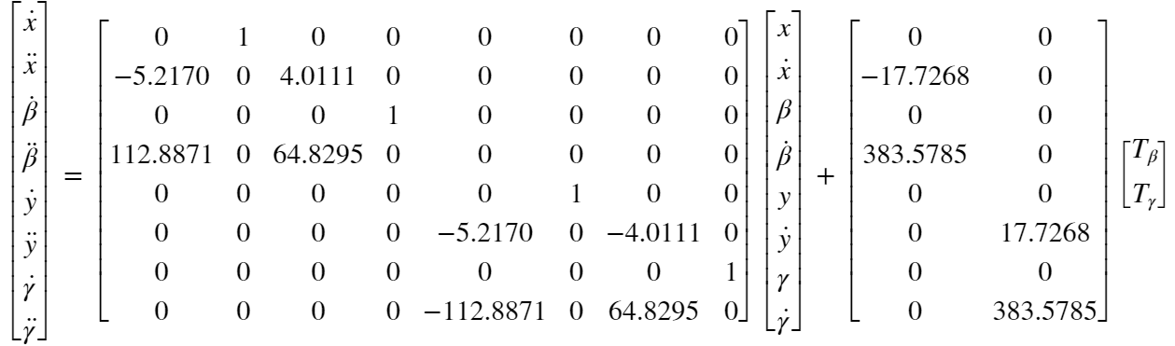

# 

# Output Equation

We are interested in controlling the entire state vector to zero, so ideally, the output to state coupling matrix should be the identity. This is only possible if it is conceivable to measure the entire state vector - in our case, with the following measurement methods, it is not:

* The u-joint angles  and  can be measured with an optical encoder. These measurements, however, would need to be differentiated to get the estimates of  and  - a process of state observation.
* The  and  locations along the plate's surface of the ball are measurable using the touch pad attached to the plate. The  and  states are therefore outputs of our system.

We will assume that the output to input coupling matrix is zero since we are not interested in having the actuation torques as feedback, nor are we interested in constructing an observer using the applied torque as an output. We also will assume unity measurement gain on the entire state vector ,, and  states, but this does not influence the output equation. The output equation  becomes:

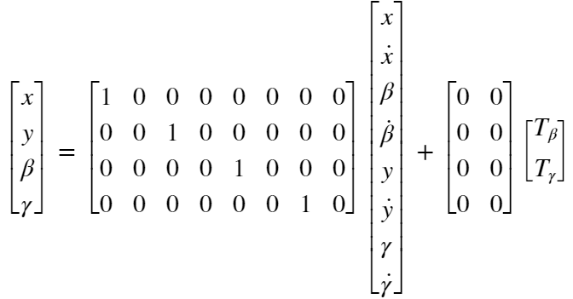

# Find the System Transfer Function

If we have designed an observer for the system that grants us access to the entire state vector, the new observed output vector , will be the state vector  and the C matrix,  will be the identity. The D matrix will change as well to reflect the higher dimensionality of the output:



The system transfer function can be found using the formula , and it reflects eight different nonzero input to output relationships, one for each of the states in .

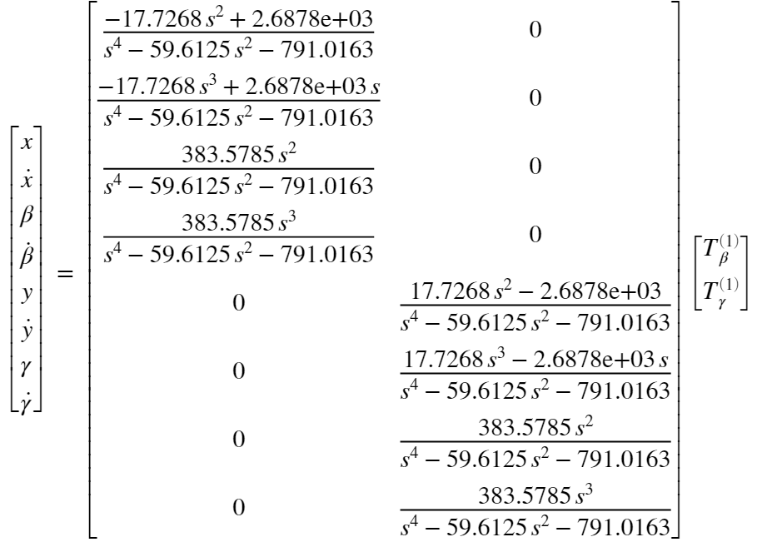

Controllability and Observability of the Linearized System

The controllability and observability of the linearized system are discussed here. The system was found to be fully controllable and fully observable.

# Controllability

The controllability matrix  is found from the linearized  matrix and the input matrix .



The system is fully controllable if rank() = 8, i.e., that it is full rank -  is an 8x32 matrix.

rank_P = rank(P)

max_rank_P = min(size(P))

controllability = rank(P) == max_rank_P

rank_P = 8

max_rank_P = 8

controllability = *logical*

1

The system is fully controllable because  is full rank.

# Observability

The observability matrix  is found from the linearized  matrix and the output to state coupling matrix  (*not* , since that matrix only applies once an observer has been designed). A picture containing table

The system is fully observable if rank() = 8, i.e., that it is full rank -  is a 32x8 matrix.

rank_Q = rank(Q)

max_rank_Q = min(size(Q))

observability = rank(Q) == max_rank_Q

rank_Q = 8

max_rank_Q = 8

observability = *logical*

1

The system is fully controllable because Q is full rank.